**ASSIGNMENT 5.3**

**on**

**Apache Spark**

**Submitted by:**

**Haseebullah Shaikh (2303.KHI.DEG.015)**

**and**

**Faiza Gulzar Ahmed (2303.khi.deg.001)**

**Solution:**

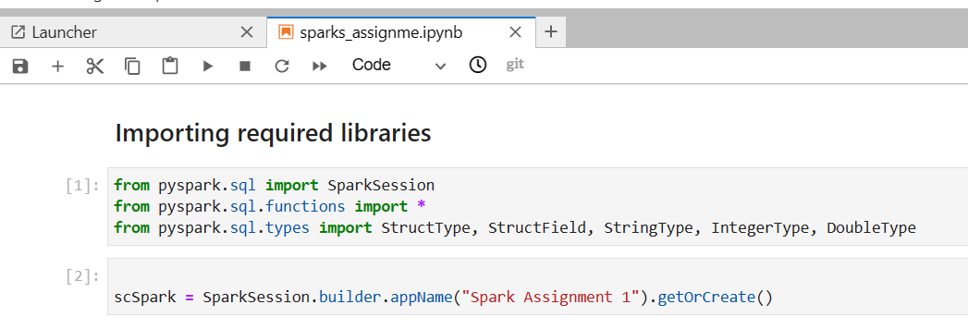

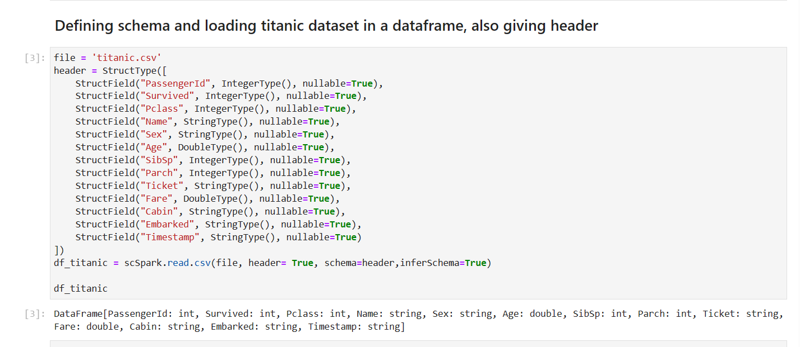

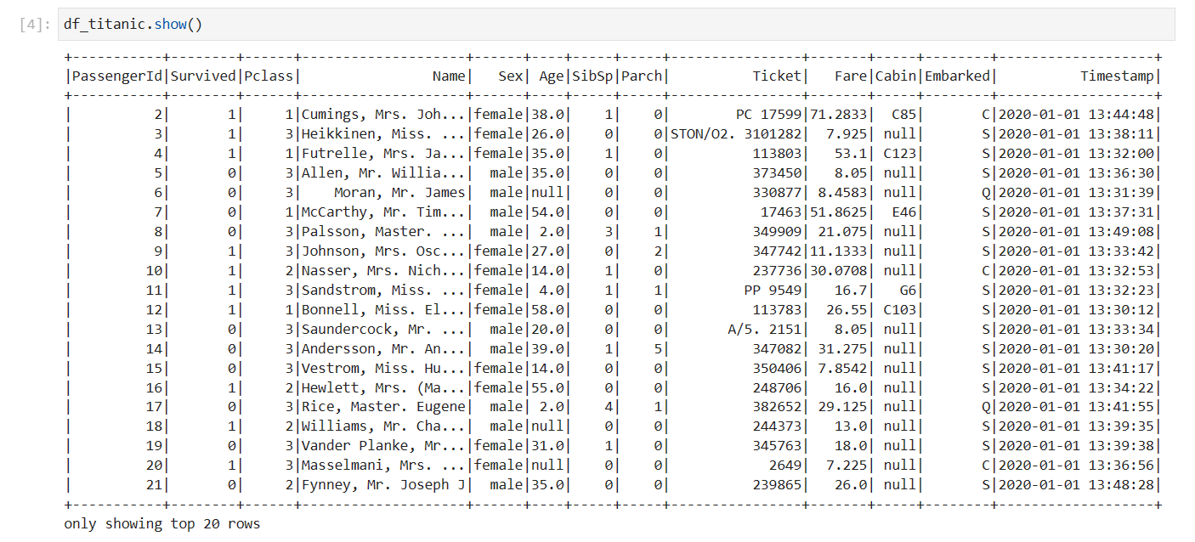

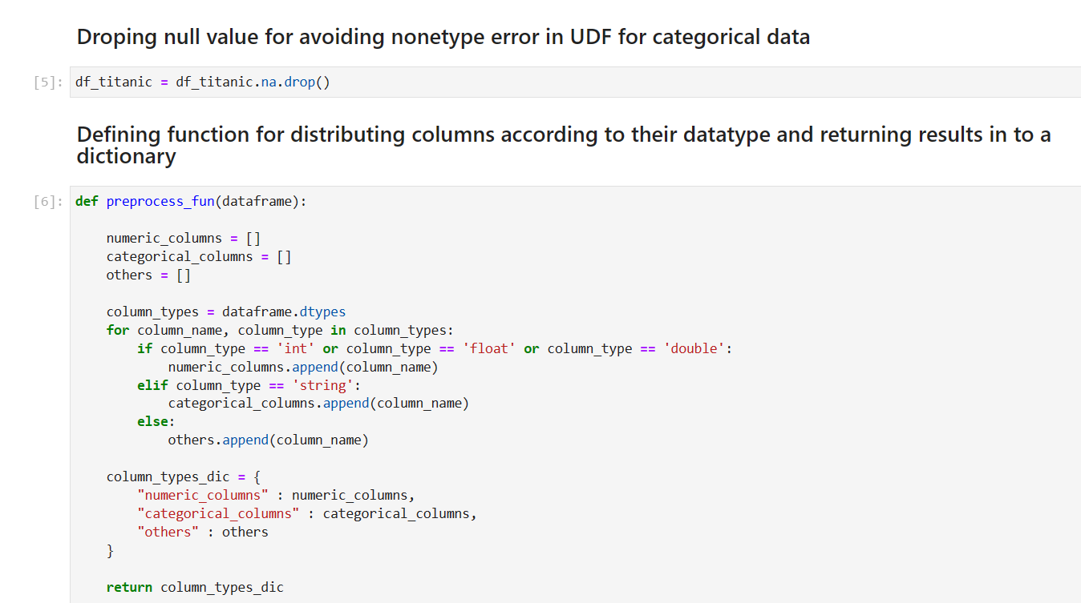

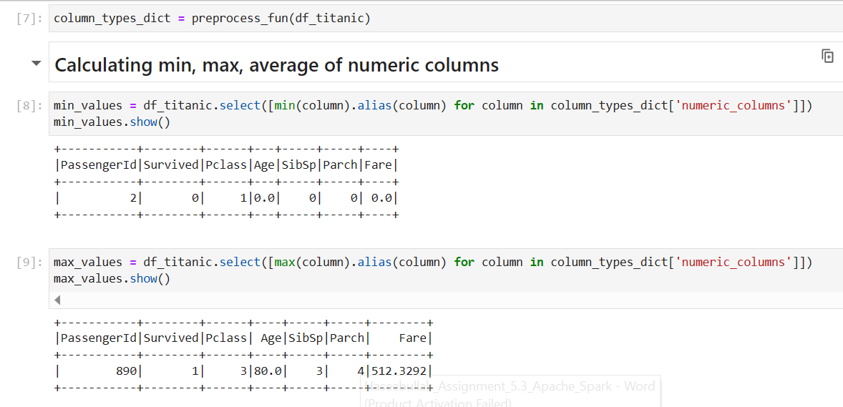

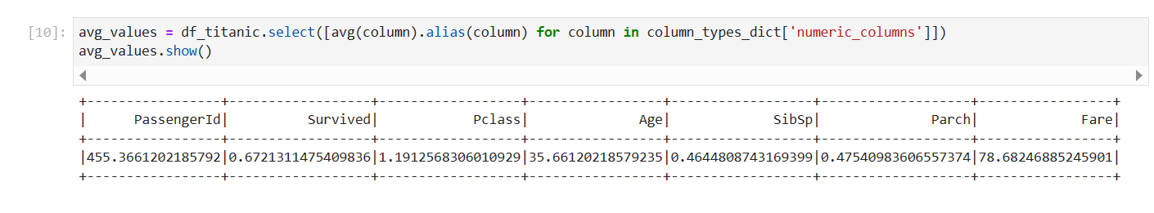

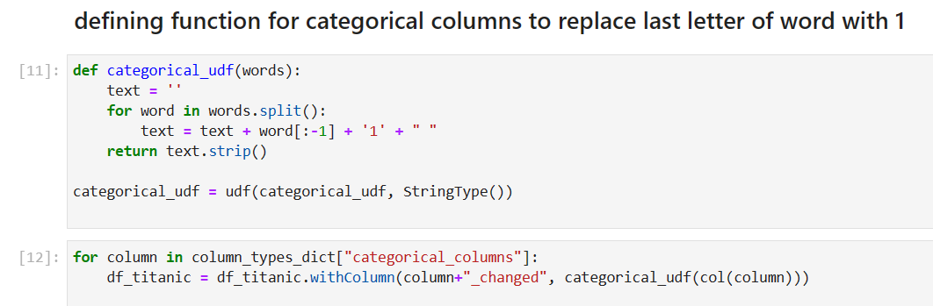

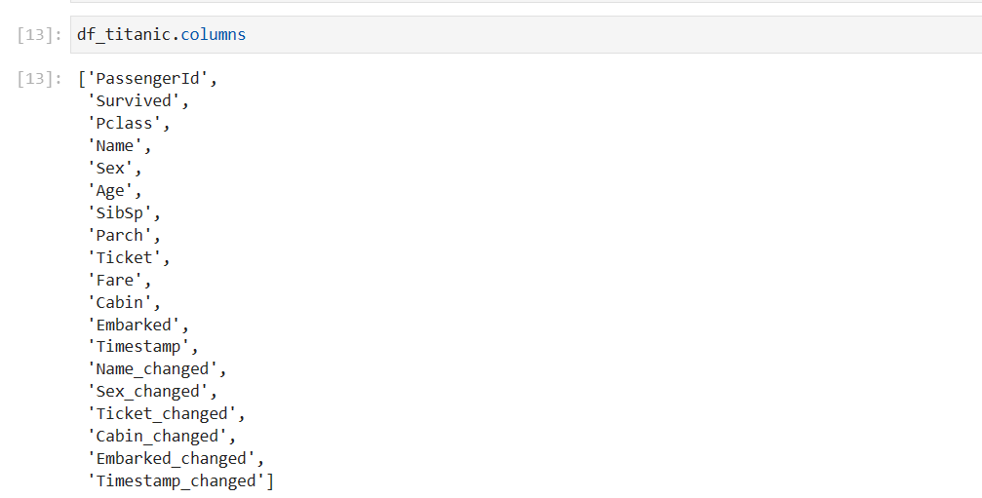

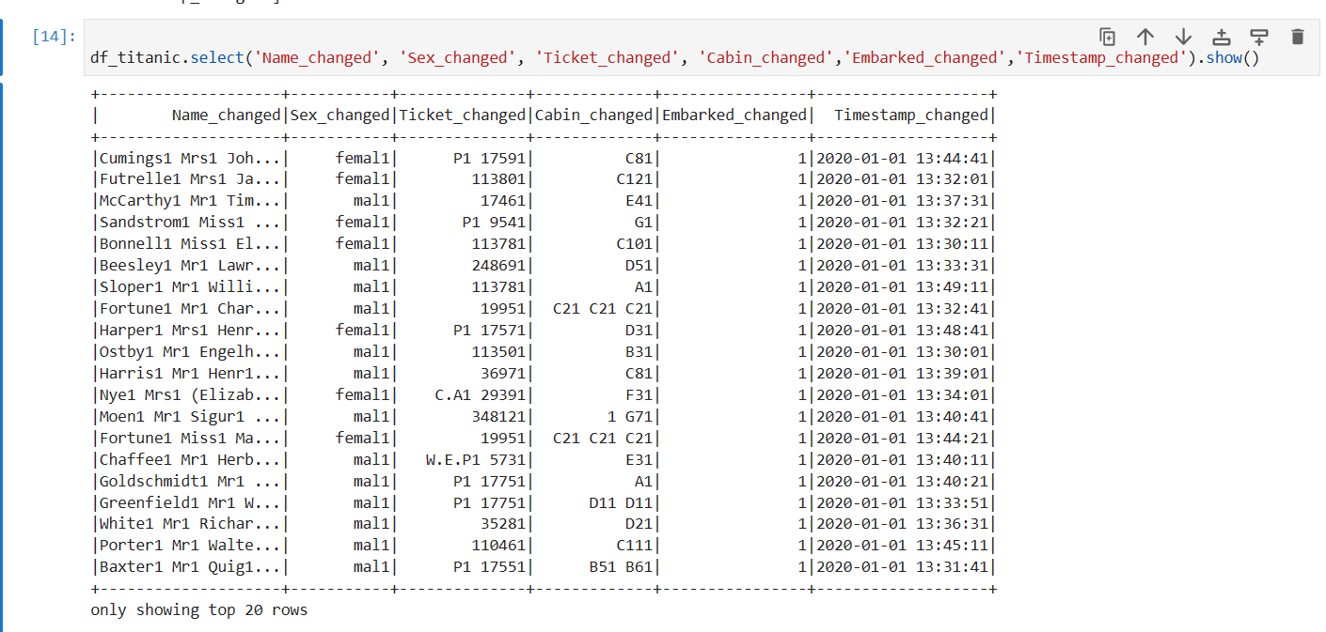

**The End ☺**